Compétence 2 : Concevoir une base de données
BON APP

1. DICTIONNAIRE DE DONNÉES

2. MCD

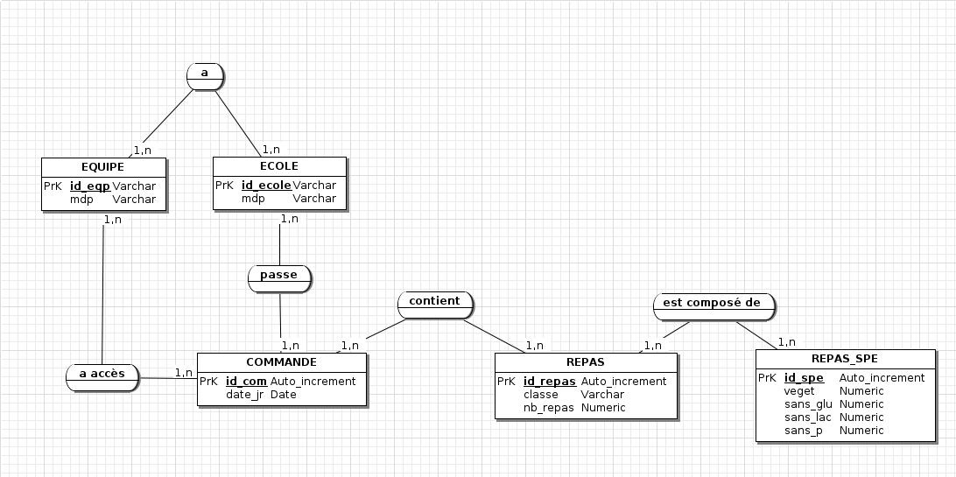

3. MLD

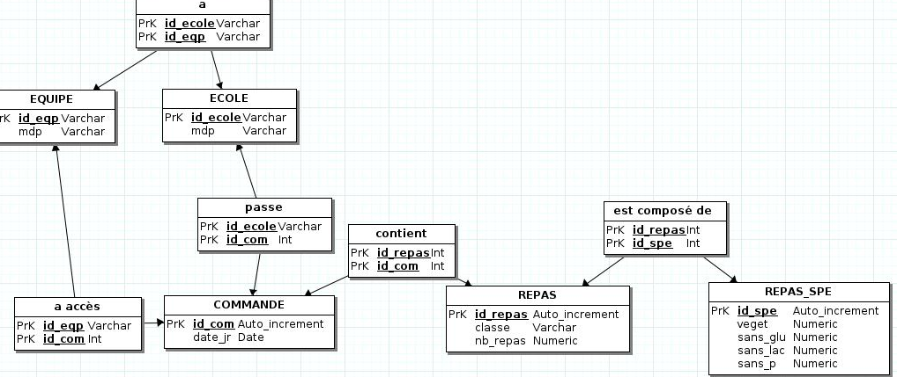

4. SGBD CHOISI



5. MPD

#------------------------------------------------------------
# Script MySQL.
#------------------------------------------------------------

#------------------------------------------------------------
# Table: ECOLE
#------------------------------------------------------------

CREATE TABLE ECOLE(
id_ecole Varchar (50) NOT NULL ,
mdp Varchar (200) NOT NULL ,
PRIMARY KEY (id_ecole )
)ENGINE=InnoDB;

#------------------------------------------------------------
# Table: EQUIPE
#------------------------------------------------------------

CREATE TABLE EQUIPE(
id_eqp Varchar (50) NOT NULL ,
mdp Varchar (200) NOT NULL ,
PRIMARY KEY (id_eqp )
)ENGINE=InnoDB;

#------------------------------------------------------------
# Table: REPAS
#------------------------------------------------------------

CREATE TABLE REPAS(
id_repas int (11) Auto_increment NOT NULL ,
classe Varchar (50) NOT NULL ,
nb_repas Numeric NOT NULL ,
PRIMARY KEY (id_repas )
)ENGINE=InnoDB;

#------------------------------------------------------------
# Table: COMMANDE
#------------------------------------------------------------

CREATE TABLE COMMANDE(
id_com int (11) Auto_increment NOT NULL ,
date_jr Date NOT NULL ,
PRIMARY KEY (id_com )
)ENGINE=InnoDB;

#------------------------------------------------------------
# Table: REPAS_SPE
#------------------------------------------------------------

CREATE TABLE REPAS_SPE(
id_spe int (11) Auto_increment NOT NULL ,
veget Numeric NOT NULL ,
sans_glu Numeric NOT NULL ,
sans_lac Numeric NOT NULL ,
sans_p Numeric NOT NULL ,
PRIMARY KEY (id_spe )
)ENGINE=InnoDB;

#------------------------------------------------------------
# Table: a
#------------------------------------------------------------

CREATE TABLE a(
id_ecole Varchar (50) NOT NULL ,
id_eqp Varchar (50) NOT NULL ,
PRIMARY KEY (id_ecole ,id_eqp )
)ENGINE=InnoDB;

#------------------------------------------------------------
# Table: passe
#------------------------------------------------------------

CREATE TABLE passe(
id_ecole Varchar (50) NOT NULL ,
id_com Int NOT NULL ,
PRIMARY KEY (id_ecole ,id_com )
)ENGINE=InnoDB;

#------------------------------------------------------------
# Table: contient
#------------------------------------------------------------

CREATE TABLE contient(
id_repas Int NOT NULL ,
id_com Int NOT NULL ,
PRIMARY KEY (id_repas ,id_com )
)ENGINE=InnoDB;

#------------------------------------------------------------
# Table: est composé de
#------------------------------------------------------------

CREATE TABLE est_compose_de(
id_repas Int NOT NULL ,
id_spe Int NOT NULL ,
PRIMARY KEY (id_repas ,id_spe )
)ENGINE=InnoDB;

#------------------------------------------------------------
# Table: a accès
#------------------------------------------------------------

CREATE TABLE a_acces(
id_eqp Varchar (50) NOT NULL ,
id_com Int NOT NULL ,
PRIMARY KEY (id_eqp ,id_com )
)ENGINE=InnoDB;

ALTER TABLE a ADD CONSTRAINT FK_a_id_ecole FOREIGN KEY (id_ecole) REFERENCES ECOLE(id_ecole);
ALTER TABLE a ADD CONSTRAINT FK_a_id_eqp FOREIGN KEY (id_eqp) REFERENCES EQUIPE(id_eqp);
ALTER TABLE passe ADD CONSTRAINT FK_passe_id_ecole FOREIGN KEY (id_ecole) REFERENCES ECOLE(id_ecole);
ALTER TABLE passe ADD CONSTRAINT FK_passe_id_com FOREIGN KEY (id_com) REFERENCES COMMANDE(id_com);
ALTER TABLE contient ADD CONSTRAINT FK_contient_id_repas FOREIGN KEY (id_repas) REFERENCES REPAS(id_repas);
ALTER TABLE contient ADD CONSTRAINT FK_contient_id_com FOREIGN KEY (id_com) REFERENCES COMMANDE(id_com);
ALTER TABLE est_compose_de ADD CONSTRAINT FK_est_compose_de_id_repas FOREIGN KEY (id_repas) REFERENCES REPAS(id_repas);
ALTER TABLE est_compose_de ADD CONSTRAINT FK_est_compose_de_id_spe FOREIGN KEY (id_spe) REFERENCES REPAS_SPE(id_spe);
ALTER TABLE a_acces ADD CONSTRAINT FK_a_acces_id_eqp FOREIGN KEY (id_eqp) REFERENCES EQUIPE(id_eqp);
ALTER TABLE a_acces ADD CONSTRAINT FK_a_acces_id_com FOREIGN KEY (id_com) REFERENCES COMMANDE(id_com);

